SUPUN

KARUNARATHNE
University Student

PROFILE
Business administration student. I consider
myself a responsible and orderly person. I am
looking forward to my first work experience.

CONTACT ME

123-456-7890

hello@reallygreatsite.com

123 Anywhere St., Any City, ST 12345

EDUCATION

BSC. (HONS) IN INFORMATION TECHNOLOGY
UNIVERSITY OF COLOMBO
CGPA - 3.48 (Upto Level 4 Semester 1) 2021 - 2025

PROJECTS

Predictive Analysis for Multiple Chronic
Diseases Fourth Year Research Based Group Project






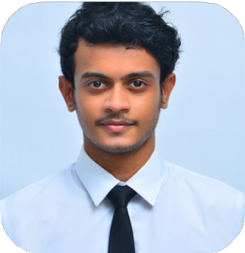
LANGUAGES
English Sinhala

REFREES
Mrs. M.N Chandimali Lecturer University of Colombo Faculty of
Technology Department Of Information
Technology
email: nipunic@uom.lk
Mobile: +94 71 079 2617

TECHNICAL SKILLS

Programming Languages: Java
Python C
JavaScript

ACHIEVEMENTS

Participated in Hackmoral 5.0 (2023) Coding competition organized by
INTECS, Faculty of IT, University of Moratuwa

